Reconstructive Memory Experiment
DISCUSSION + REFERENCES ASSIGNMENT
•A summary of results using words, not numbers.
•Main substance is to interpret the findings of our weekly experiment using research on reconstructive memory.
•Must cite 2 sources (Roediger & McDermott, 1995; one other from post-experiment video or can find your own)
•Also need References
Things to consider:
•What were the main findings of our study?
•Were our results expected? Are they consistent with other related studies?
•What do our results tell us about reconstructive memory?
•What were limitations and how should we address these?
•What are the practical implications of our research?

Your Discussion section should look like:-
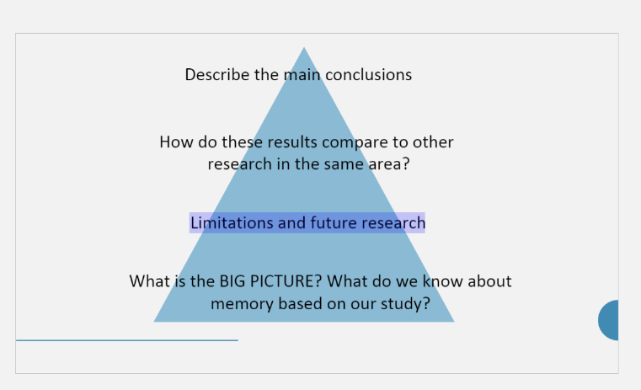
CHECKLIST (please include each of the following)
1.What were our results?
2.Did our results support our hypothesis?
3.How do our results compare to other relevant research that has been done?
4.How can this past research help us understand our results?
5.What are the theoretical and practical implications of our results?
6.What are some possible limitations to our study?
7.What should future research do in order to further address this topic?
8.Wrap up with big take-away

Assignment Overview:
- Write a discussion section for the Reconstructive Memory Experiment you completed. Your assignment should include:
  - Title page
  - Discussion section
  - References
Assignment Details:
- For this Discussion section, your paper doesn't need to be as lengthy or comprehensive as what you'd find in a typical journal article. Just make sure you answer the questions mentioned above.

- Include at least two sources in your Discussion section that are included in your References page. One should be Roediger & McDermott (1995), and one can be found on your own.

- Use APA-style throughout
Resources:
- To search for references in PsycINFO, Google Scholar ) is another great resource.
- For a great source on APA Style, go to the Purdue Online Writing Lab ).

